Extra information to prepare to attend the Flourishing event
A few things for parents and carers to know before the day:
We want our first Flourishing Connection Event to feel relaxed, welcoming and enjoyable for everyone. There is no right or wrong way to take part.
- No pressure, no expectations. Children and young people are welcome to join in as much or as little as they feel comfortable with. Watching, exploring, staying close to a parent or getting involved in activities are all equally valued. We want every child to leave feeling that their experience was a success, whatever that looked like for them.
- Child-led and low demand. The day is designed to give children opportunities to explore, play and make connections naturally, at their own pace. It's also a chance for parents and carers to meet others who may share similar experiences. The Flourishing team will be around to gently support connections and, we hope, begin growing a wider network of familiar, trusted people over time.
- Freedom to explore and create. Resources and activities in the main field can be used imaginatively and flexibly, provided everyone stays safe. Families are very welcome to bring along an activity or something to share, but there is absolutely no expectation to do so.
- Refreshments. We'll have free tea, coffee and biscuits available in the main field. Feel free to bring a camping mug if you'd like! The farm café is also available if you fancy a visit.
- Kindness, understanding and respect. We recognise that children communicate their feelings and needs in different ways, including through their behaviour. Our approach is to respond with curiosity, compassion and without judgement. If challenges or disagreements arise, we'll work together to navigate them calmly and respectfully.
- Everyone belongs. Inclusion is at the heart of Flourishing. We welcome difference, celebrate individuality and recognise that what works for one child may not work for another. We believe belonging should never depend on fitting a particular mould.
Above all, we hope you and your children can come as you are, feel comfortable being yourselves and enjoy the opportunity to connect.
As we are holding this as a pilot event and really do want your feedback. Please talk to us during the event or email us/message us with any feedback at all afterwards.
Flourishinglearningnetwork@gmail.com

Please feel free to share as little or as much of this information below as you like with your young person to prepare them if they need information in advance:
I am going to a Connection Event in Ditchling on 27th October. We can arrive at any time after 10am. I will go with my grown-up.

When I arrive
We can park in either car park. My grown-up and I will find the welcome team. They will be wearing these T-shirts; I might also spot ribbons tied to things to show me where to go:
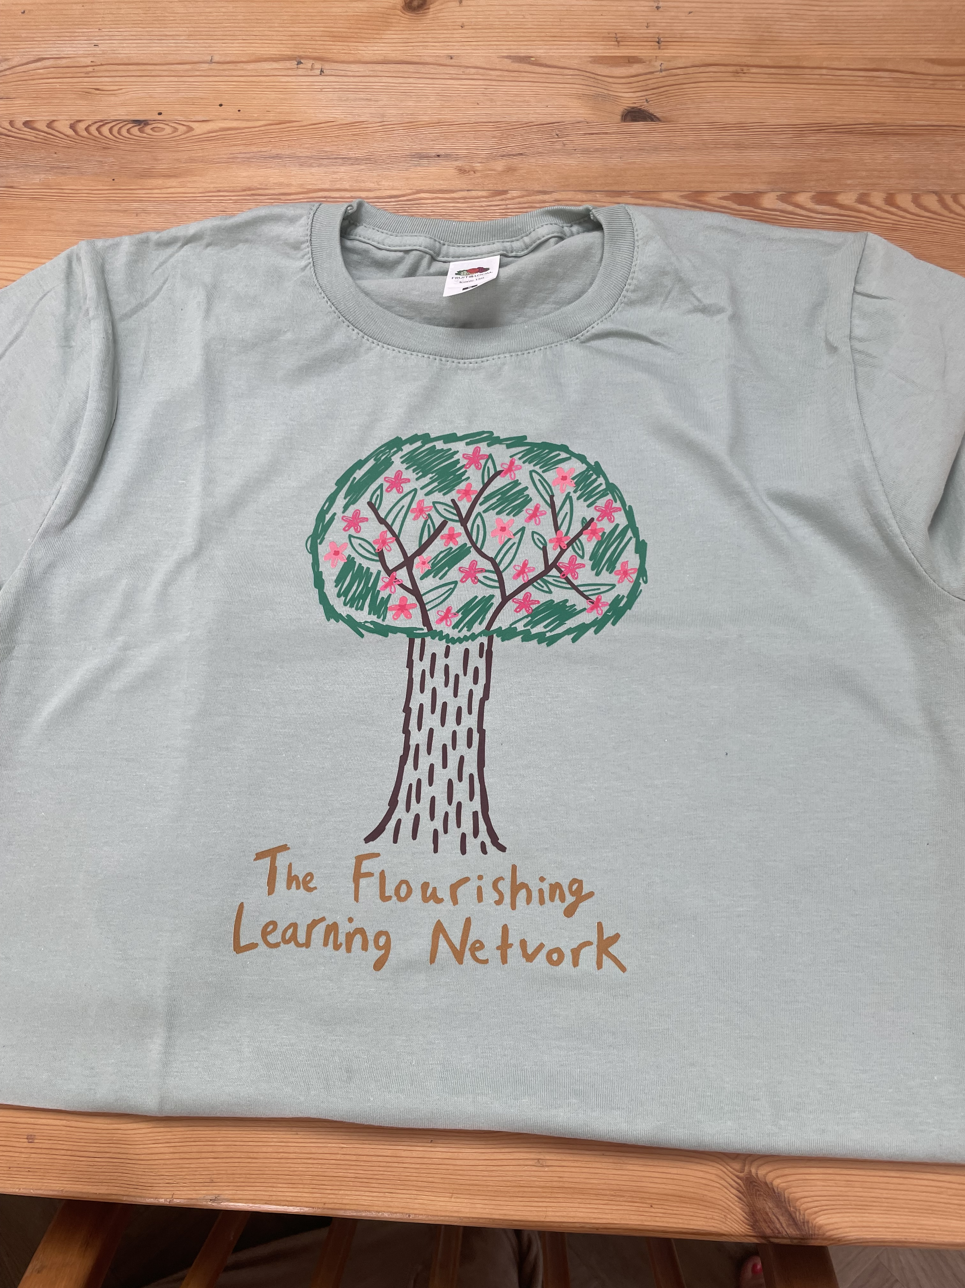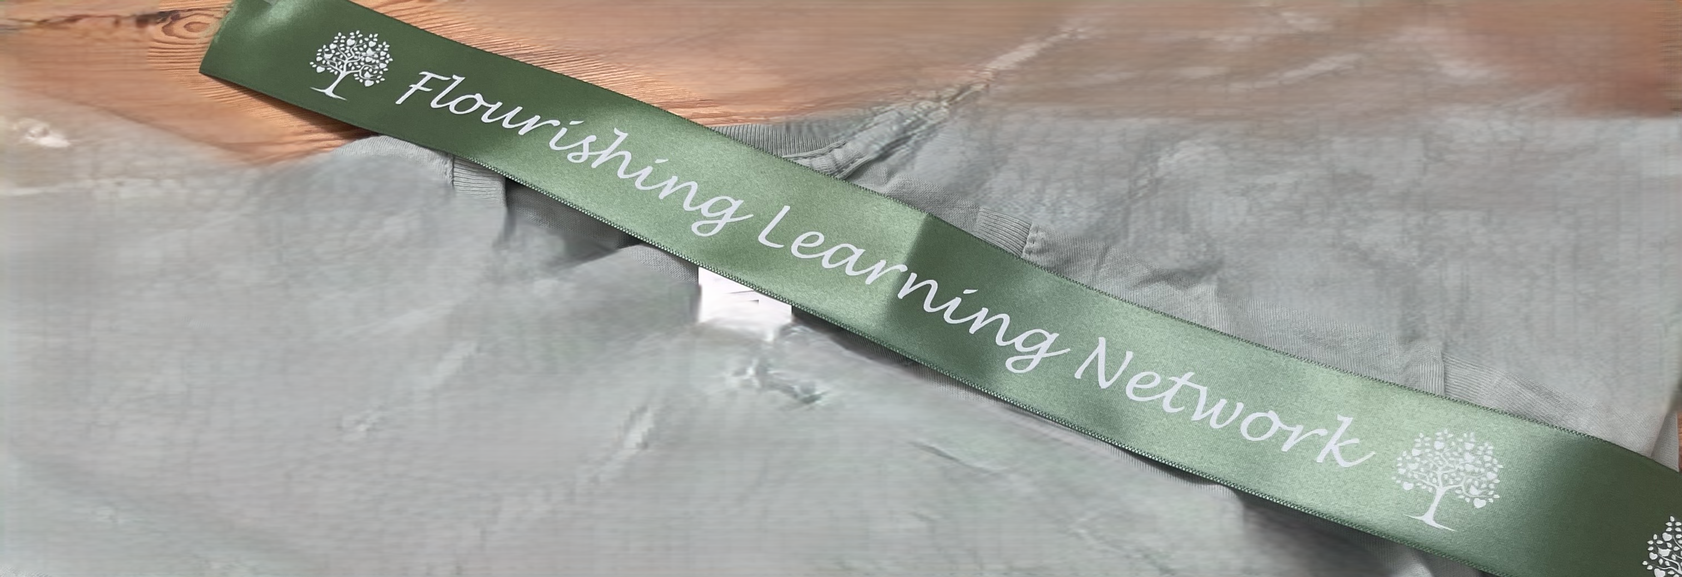

People I might meet
There will be a few other children around my age who like some of the same things as me. I can stay with my grown-up for as much of the visit as I want. I can take my time.
Places to play and explore
I can use the map on the other page, to see all the areas I can play in and explore.

Animals I might see
We can visit the animal areas. I might hear birds calling.
I can take my time looking. Some animals may be resting or hiding.
I can also feed and hold some of the animals too:
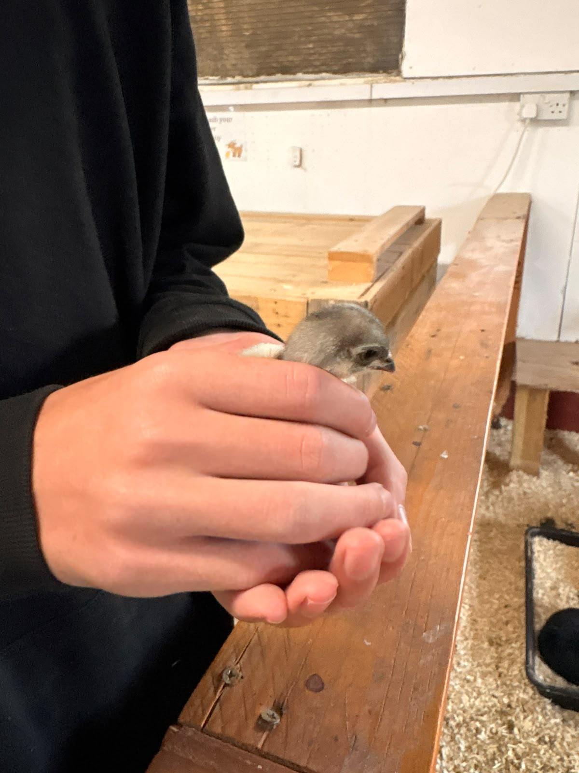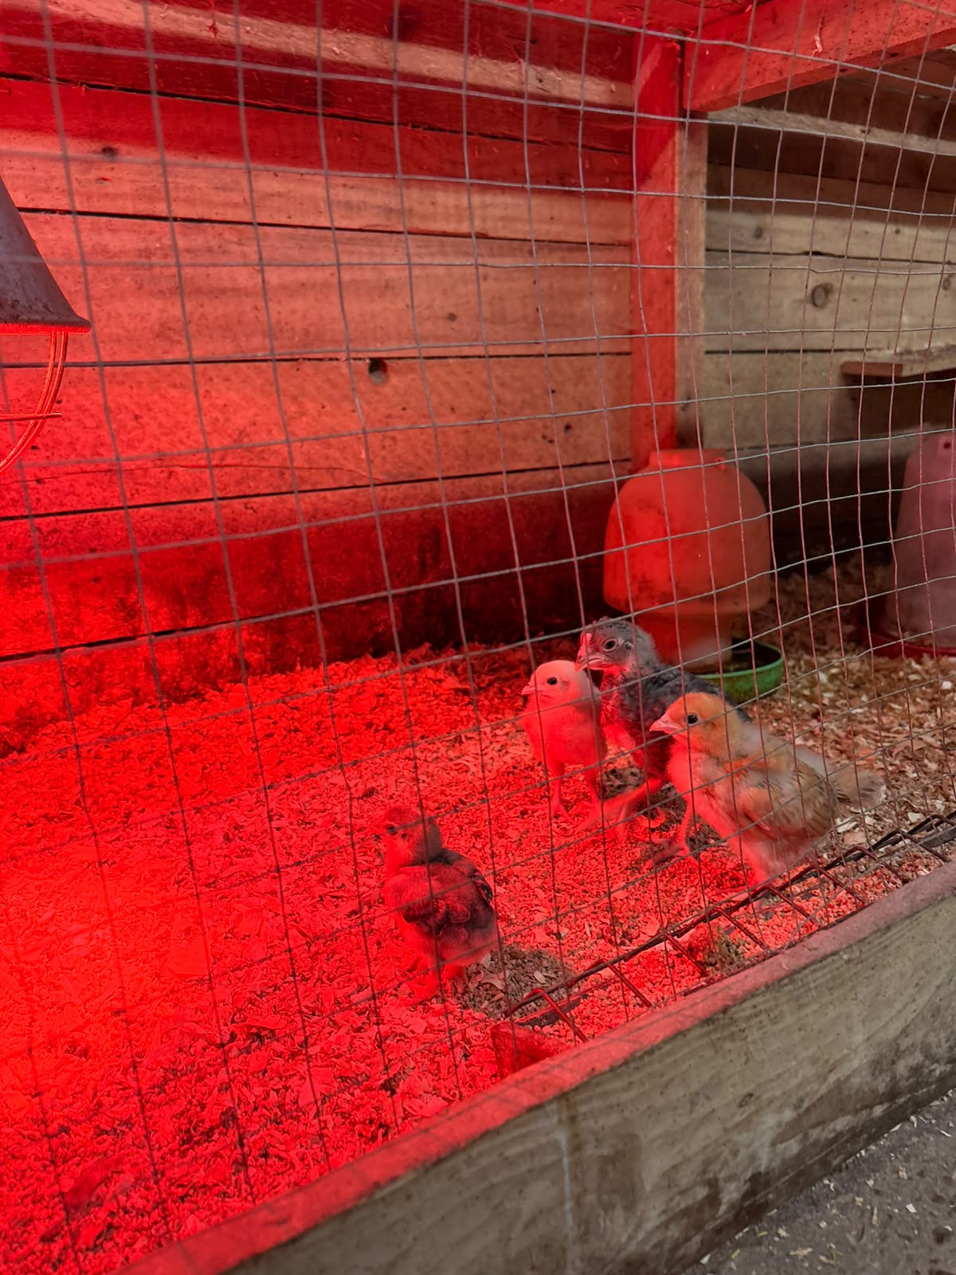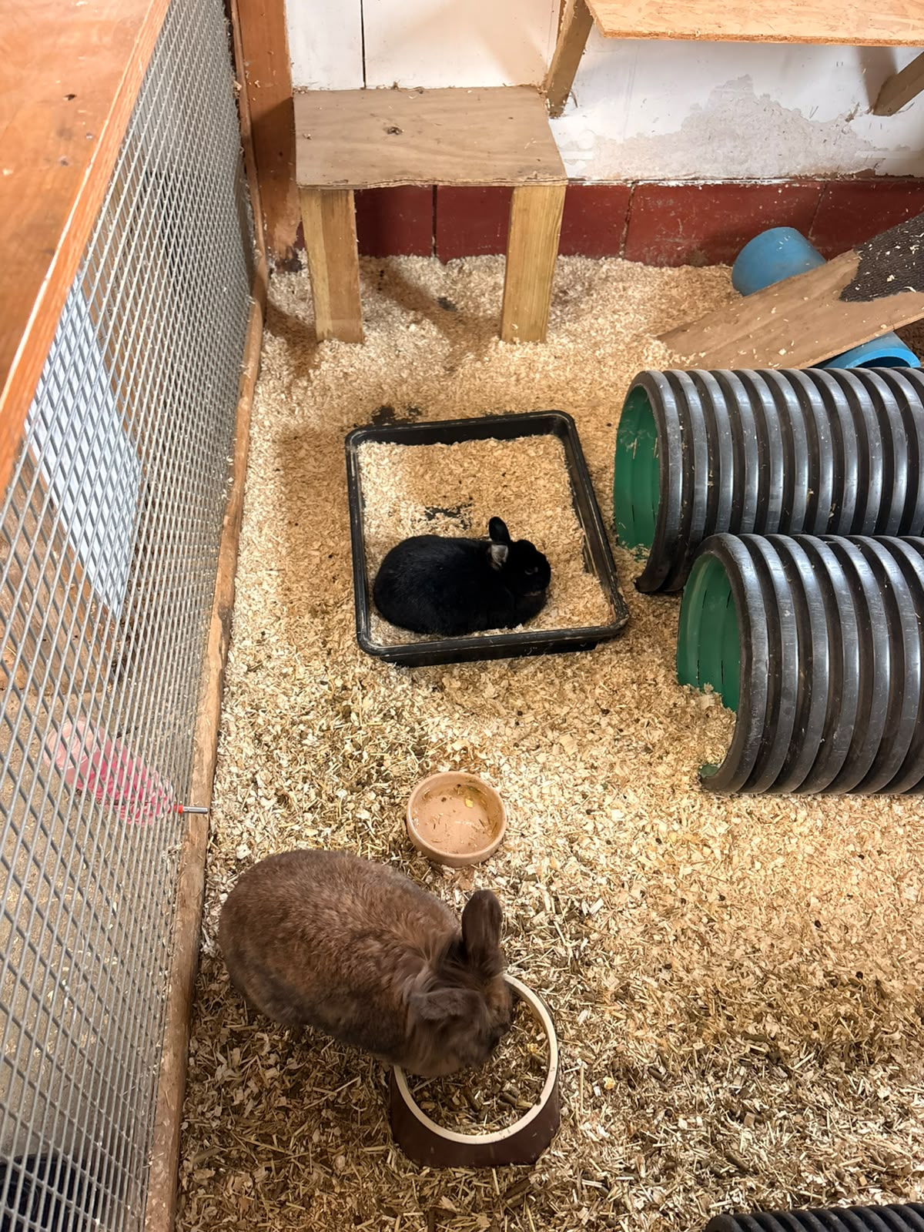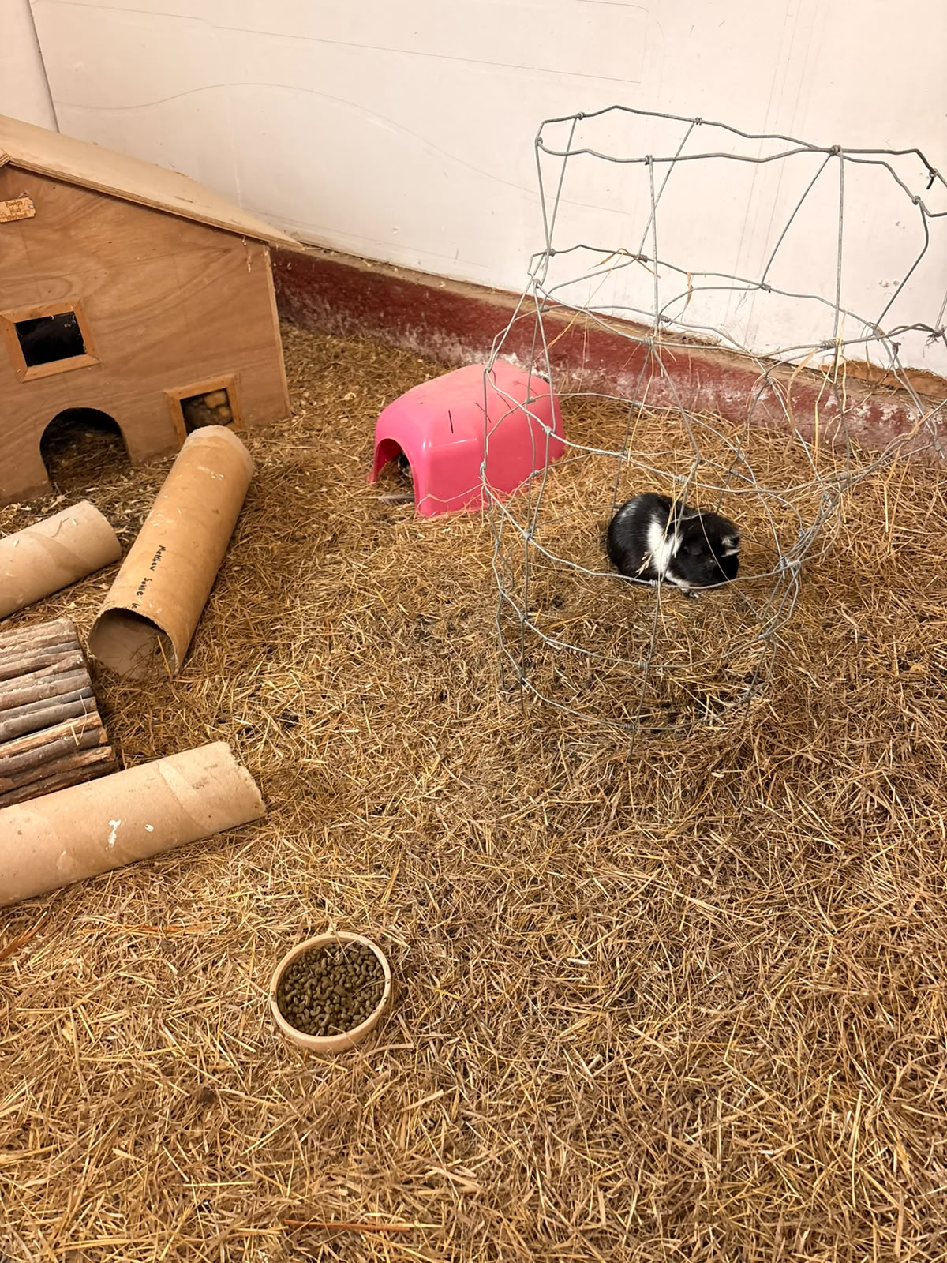
Chicks, Rabbits and Guinea Pigs

The main field
In the main field there will be some optional activities and resources for me to make things with, as well as lots of space to run and play if I like.
I can choose to make what I like, and adults can help me if I want them too. There is no set thing I must make. Some of the resources I will see there are:
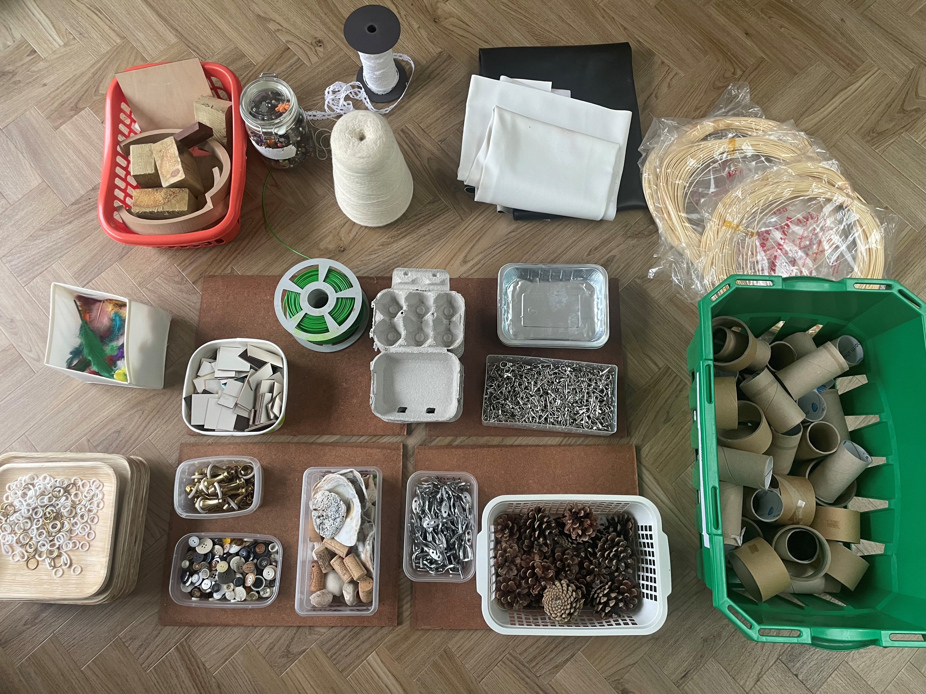

I can join in if I want to, or watch. I can look first and decide what interests me.

The fire and food
The team plans to start the fire around 11 am. There will be cooking on the fire, including marshmallows and other food
There may be a bit of smoke, a smoky smell and crackling sounds.

Choosing what to eat
We can bring our own food or have food from the team.

Going home
We can stay for a short visit or for longer. We can leave when we are ready.
There will be a chance to say how I have found the day by putting a flower token in one of these jars: “More please, it was ok, not for me”. You can tell the team what you enjoyed if you like or not.
